Population Dynamics and Initial Population Size
(Module website: http://web.as.uky.edu/Biology/faculty/cooper/Population%20dynamics%20examples%20with%20fruit%20flies/TheAmericanBiologyTeacher-PopulationDynamicsWebpage.html )

Introduction
Every population of organisms is founded by some initial population. This portion of the module will examine how characteristics of the initial population can impact how quickly the population can grow. In sexually reproducing organisms, at least one male and one female must be present in the founding population for the population to ever grow. This module focuses on a particular question; how can altering the ratio of sexes in the initial population change the rate at which the population can grow?

Hypothesis Forming
At least one male and one female are required to found a population, but is one sex more important to growth than the other? Biologically, it makes sense that one male can fertilize eggs from more than one female. Is the reverse true?
Since we are aiming to observe how altering the sex ratio can alter the rate at which a population grows, we should form a hypothesis as to what the relationship may be. Of the following hypotheses, which makes the most sense building on what you know about sexual reproduction? Why?
- Populations founded with more females will grow less quickly than similar populations founded with fewer females.
- Populations founded with more females will grow more quickly than similar populations founded with fewer females.

Experimental Design
To test our hypothesis, we must design an experiment that varies our independent variable and allows us to quantify our dependent variable. Our independent variable (amount of females in initial population) must vary across the experimental trials, and the dependent variable (rate of population growth) can then be assessed. All other variables should be held constant across the trials. For the following variables explain how you would keep them constant across trials:
- Food Availability
- Water Availability
- Space (Volume) Availability
- Temperature
- Light Exposure
- Moisture

In this module, we will use fruit flies as our model organism. They are cheap, safe, and easy to manage. Fruit flies undergo several stages during their life cycle, but we will focus on two of them: pupa and adults. Fruit fly larvae ascend in their enclosure and form a pupa, in which they undergo metamorphosis. For the first portion of the module, let’s examine pupation rates. With the conclusion of that data collection, we will go on to explore the rate at which new adults appear, a process called eclosion.
Procedure
Establishing Populations in Vials:
- Prepare six vials with a food substance.
- Obtain cotton balls, or other material that allows gas exchange, that can be used to contain flies within the vials.
- Using a piece of masking tape, label each of the six vials with the first six letters of the alphabet (A-F).
- Using CO₂, anesthetize a large vial of CS flies.
- Either with a microscope, magnifying glass, or naked eye, determine the sex of each fly and place them in piles accordingly. In order to sex each fly, you must be familiar with the characters that distinguish the two sexes. Please see the included sex-determining guide for more information.
- In three of the vials (A-C), place one male and one female fruit fly. While they are unconscious, it is important not to let them fall in the food. They may stick to it and eventually die. Instead, hold the vial on its side, and place each unconscious fly in the interior.
- Ensure the flies don’t escape by placing the cotton ball snuggly within the open end of the vial. Leave it lying on its side until the flies begin moving around.
- Once the flies have woken up, you can safely place the vial upright.
- Repeat steps 6-8 with vials D-F. Instead of using one male and one female, however, use one male and three females.
- Once you have finished establishing the populations in the vials, your setup should look like that in image below:
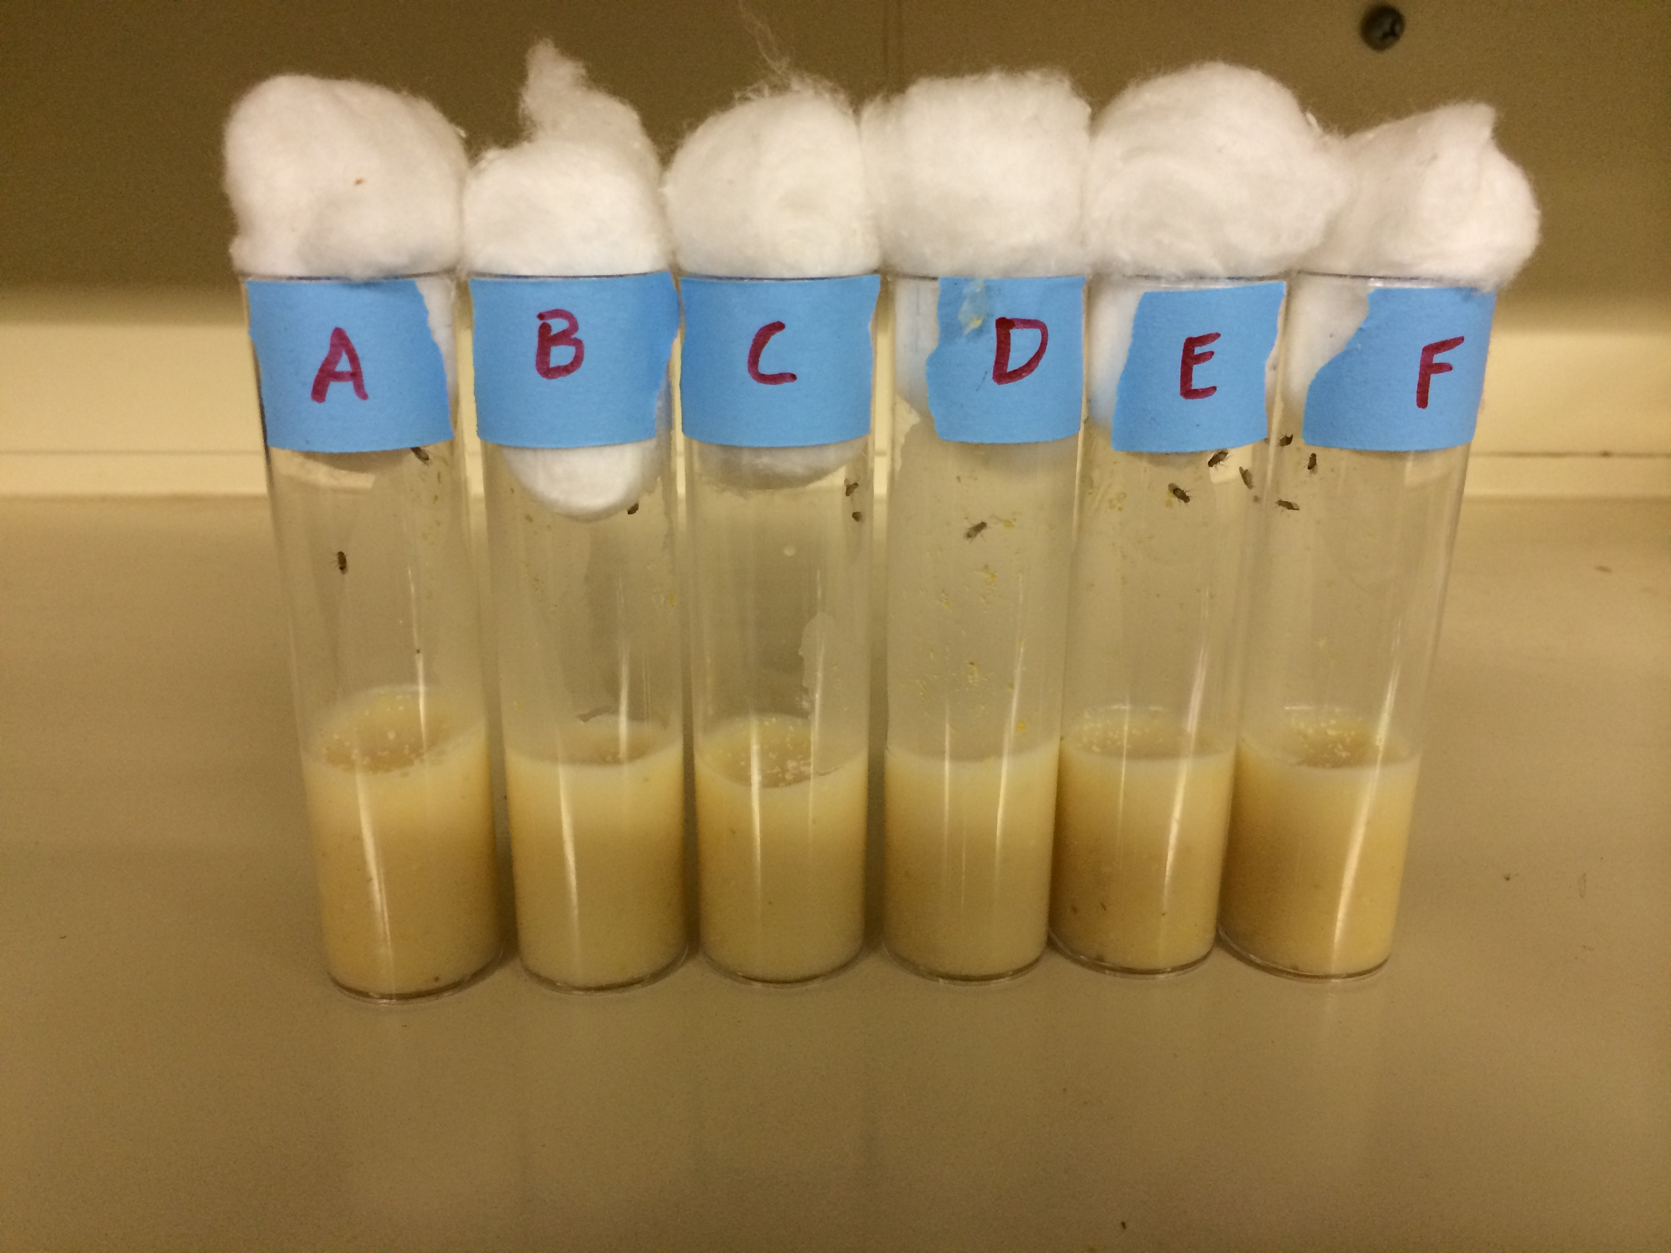
Monitoring Pupa Formation in the Vials:
- Prepare a table in which to document the date and time of each recording and the number of pupa counted at that time for each vial.
- Check each of the vials daily for the first signs of pupa formation. It may take several days to a week before pupa being to form. You will first notice the movement of larvae within the food medium. After a few days, the larvae will begin climbing on the sides of the vial walls. They will then become stationary and begin changing from a yellowish white to a much darker brown color. The color change marks the transition into the pupa stage.
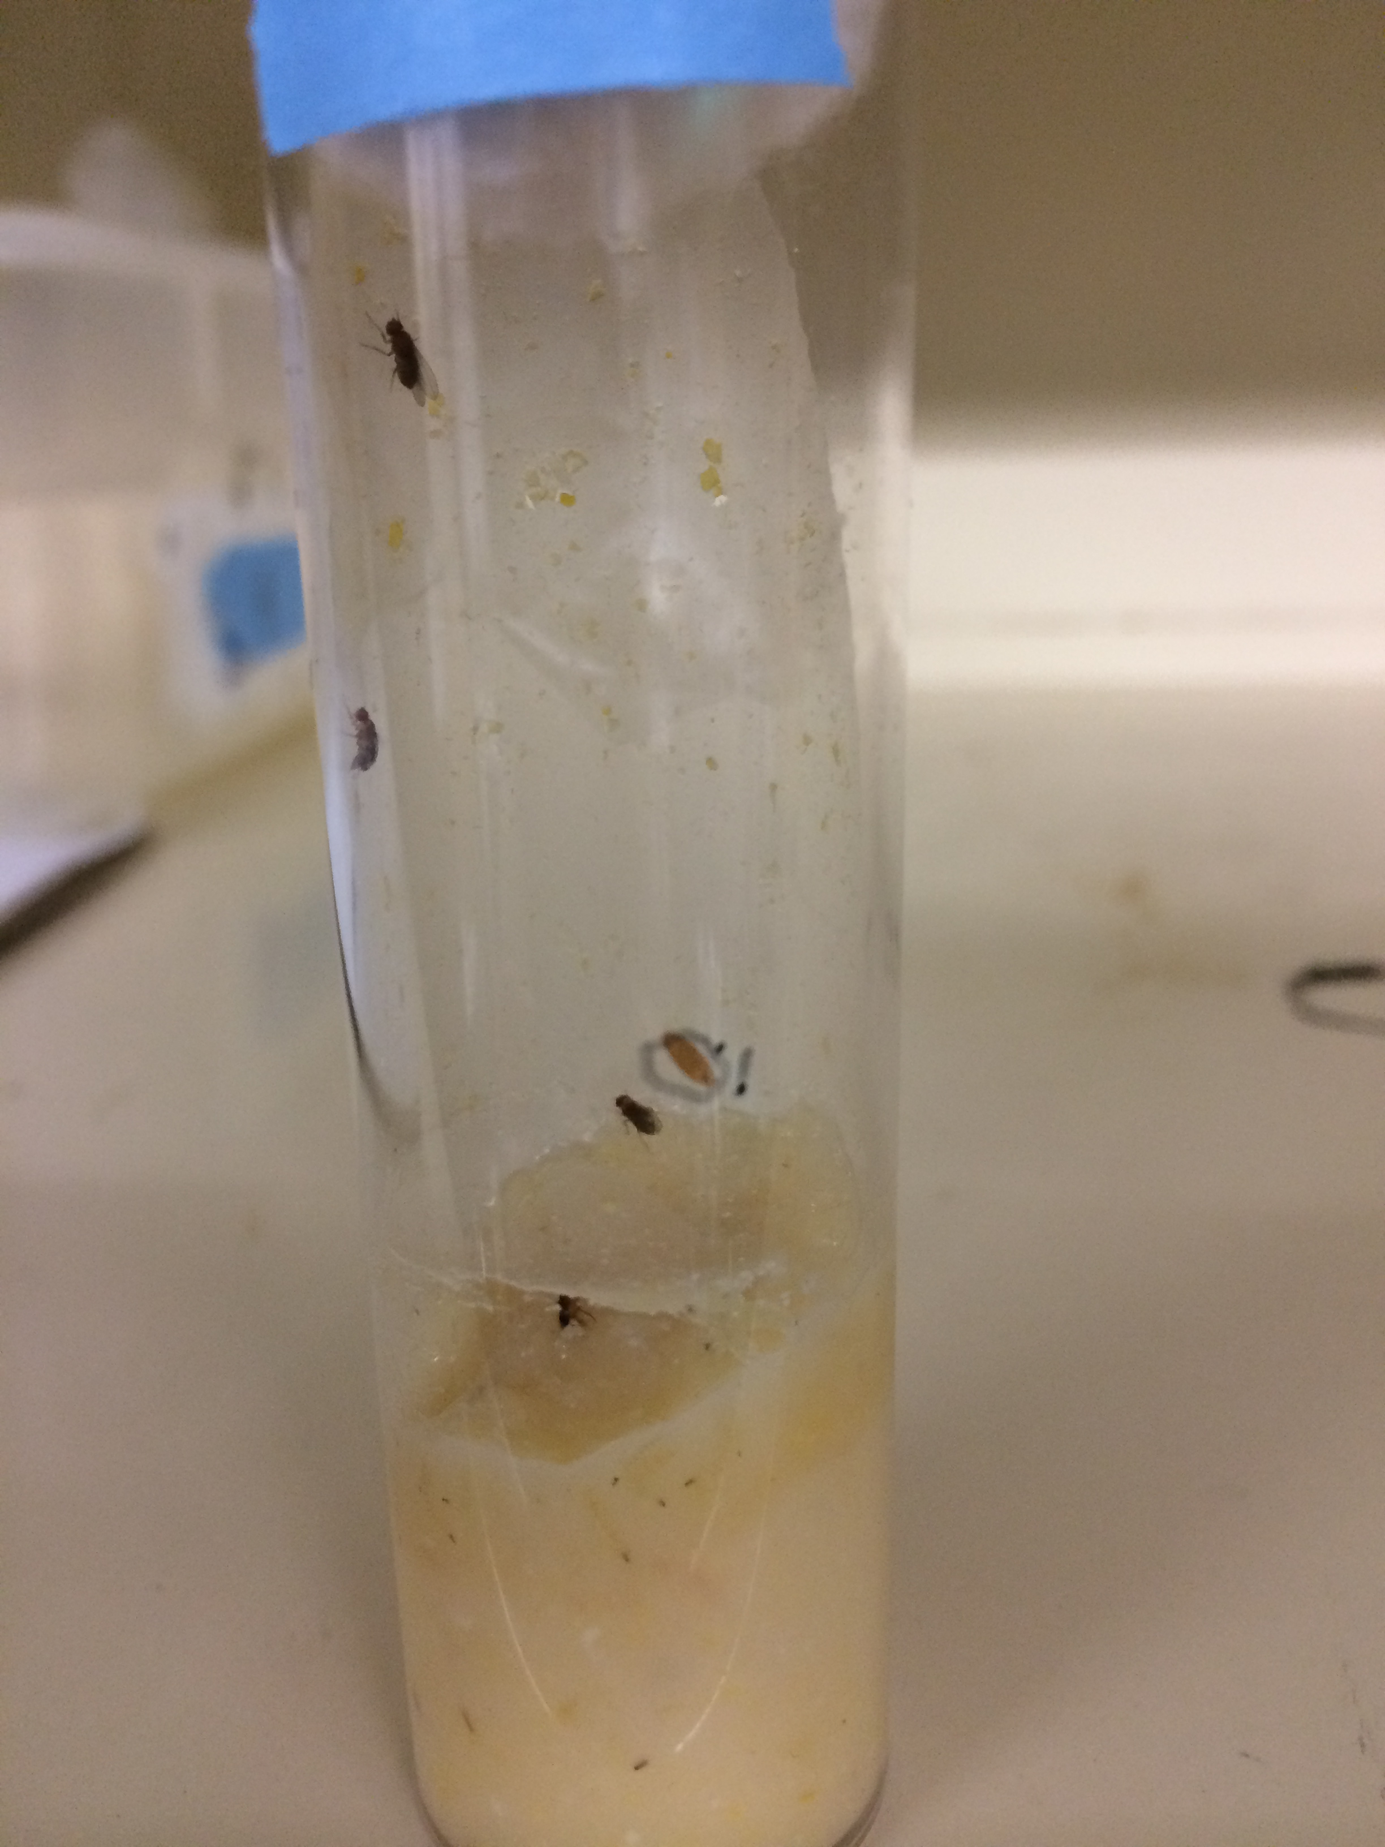
- On each vial, use a fine point marker to circle each newly formed pupa. You may number these, and then document the number counted in your table. Marking each one ensures you will not recount the same pupa. This process can be seen in the image below:

- After the first pupa forms, the vials should be monitored twice daily. Ideally, the two recordings would occur about twelve hours apart. At each instance, record the number of newly formed pupa since the last time they were counted. Continue to also use a marker to mark each pupa. Additionally, be aware of the number of adults in each vial. When new adults begin to appear (a third adult in vials A-C and a fifth in vials D-F), move on to step 5.

- Continue counting and marking the pupa twice daily until the first new adult emerges (ecloses). This should be about a week after the first pupa was documented. At the end of this process, you may notice that vials D-F have significantly more pupa than vials A-C. This is normal. The vials should look similar to those in the image below:
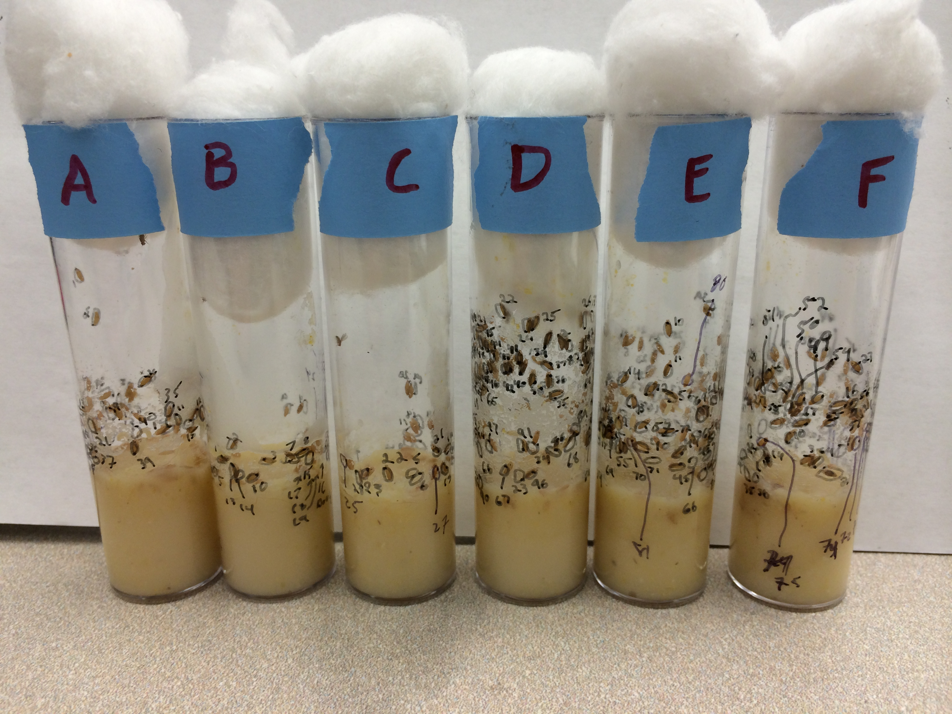

Monitoring Adult Eclosion in the Vials:
- Using the same vials and established populations from the previous section, this portion of the module starts immediately after the monitoring of pupa formation concludes.
- Prepare a table similar to the one used to document pupa formation. It should be designed to include the date and time of recording as well as the number of new adults for each vial.
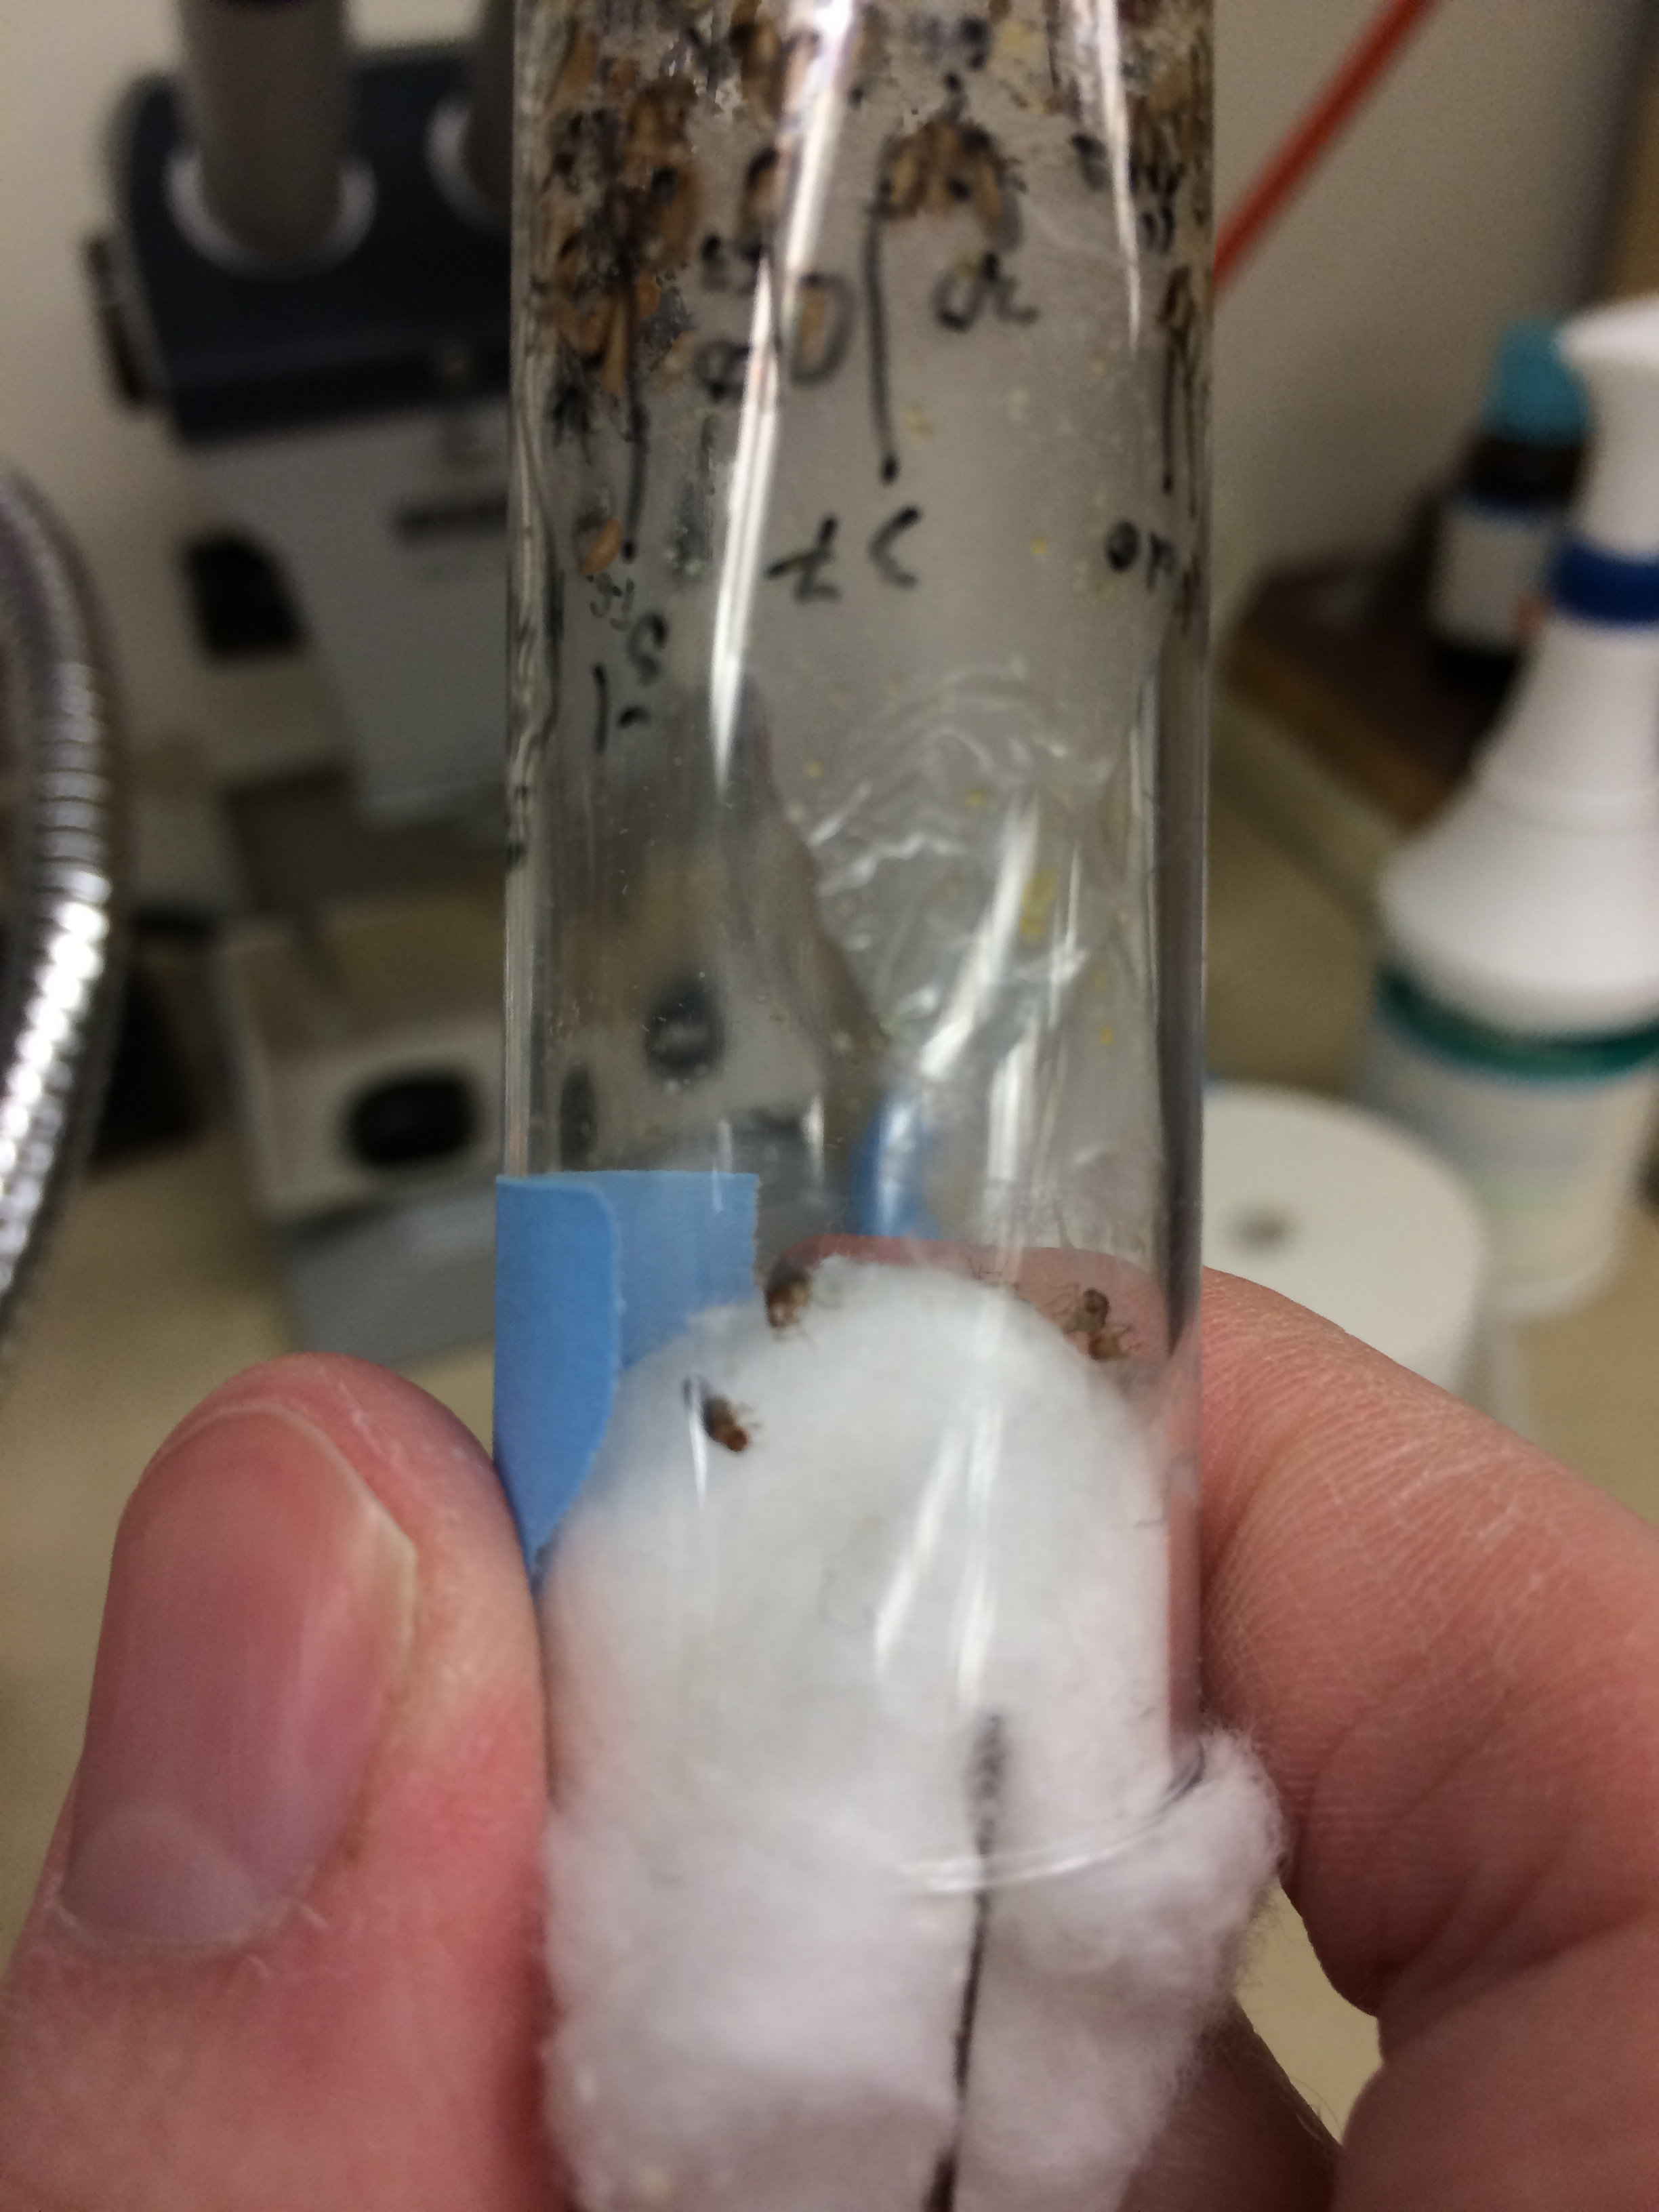
- When you notice the emergence of a new adult fly in one of the vials (this is the same point at which the previous section concludes), remove the adults from all of the vials. For example, upon noticing that vial C contains three flies instead of two, remove all adults from every vial. The flies can be released outdoors or anesthetized then killed.
- If anesthetizing the flies, invert the vial and gently tap before doing so. This is to prevent the unconscious adults from falling into the food. If they fall into the food, they may become stuck and difficult to remove from the vial. To the right, is a picture of the process being completed. The needle is attached to a CO₂ tank. Please notice the flies fell onto the cotton and not into the food.

- In your table, document the number of new adults in each vial at that point.
- Monitor the vials twice daily, ideally 12 hours apart, for the emergence of new adults. At each point, document the new adults in the table and remove the adult flies. After each time data is collected, each vial should not have any adults.
- Continue monitoring the vials for new adults until no new adults appear in all vials. If adults quit emerging in one vial before the others, just document that vial as a zero in the data table.
- This portion of the module concludes when all vials quit producing new adults or a plateauing is noticed.

Data Analysis
The first portion of data we will analyze is that regarding pupation. Please save eclosion data, for we will be getting back to it. This section will give step-by-step instructions on how to analyze this data. It will require the use of two computer programs (Excel and Joinpoint, which can be downloaded for free). The following steps will be used for pupation and eclosion, but we will work with pupation first.

Using Excel and Joinpoint to Analyze Data:
- Upon completion of data collection, you should have a table containing the number of new pupa (or adults) recorded at different times over the duration of the experiment. This data should be imported into Excel. Please visit the module website (included on the first page) to download the template.
- On the website, please watch one of the videos demonstrating how to properly input and edit the data. There are versions for both Macs and PCs. Some steps are only described in the videos, so please pay attention. (Note: screenshots are taken on a Macintosh running Excel 2011. Some items and options may appear differently on your computer):
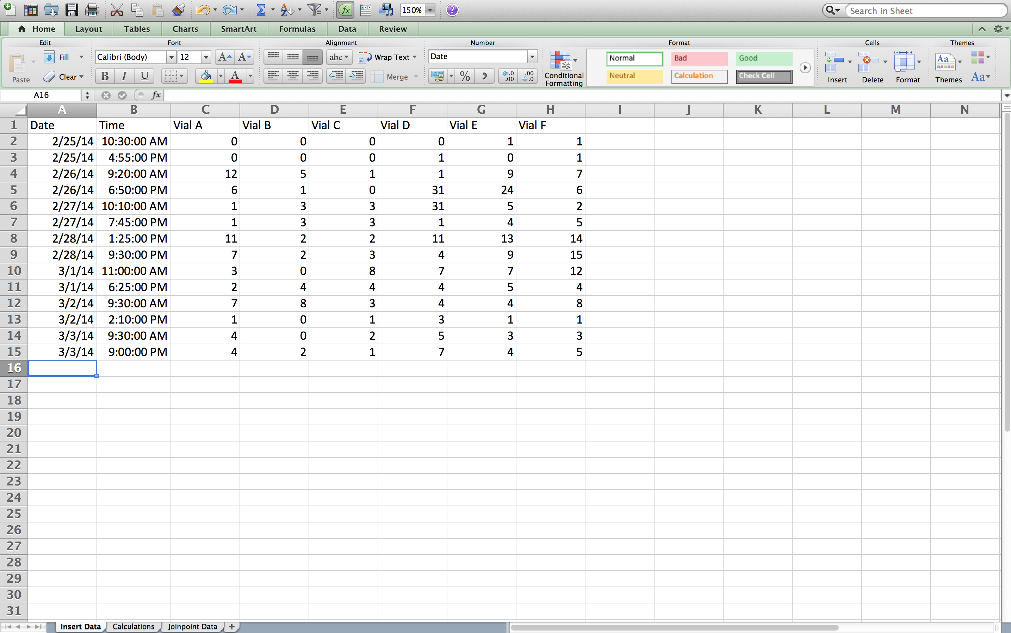

- The calculations portion of the spreadsheet contains all of the functions that need to be carried out. It will pull data from the “Insert Data” tab to be used in the calculations. From this analysis the only calculated information needed is the average total of pupa (or adults) at each time for the two treatment levels (two initial flies or four initial flies) and the total hours elapsed at each data point. This data will appear in the “Joinpoint Data” tab.
- To next portion of the analysis will occur in Joinpoint software. Go to the tab called “Joinpoint Data,” and go to File, then Save As…
- Under “Format” choose “Windows Formatted Text (.txt)” and choose a location you will remember.
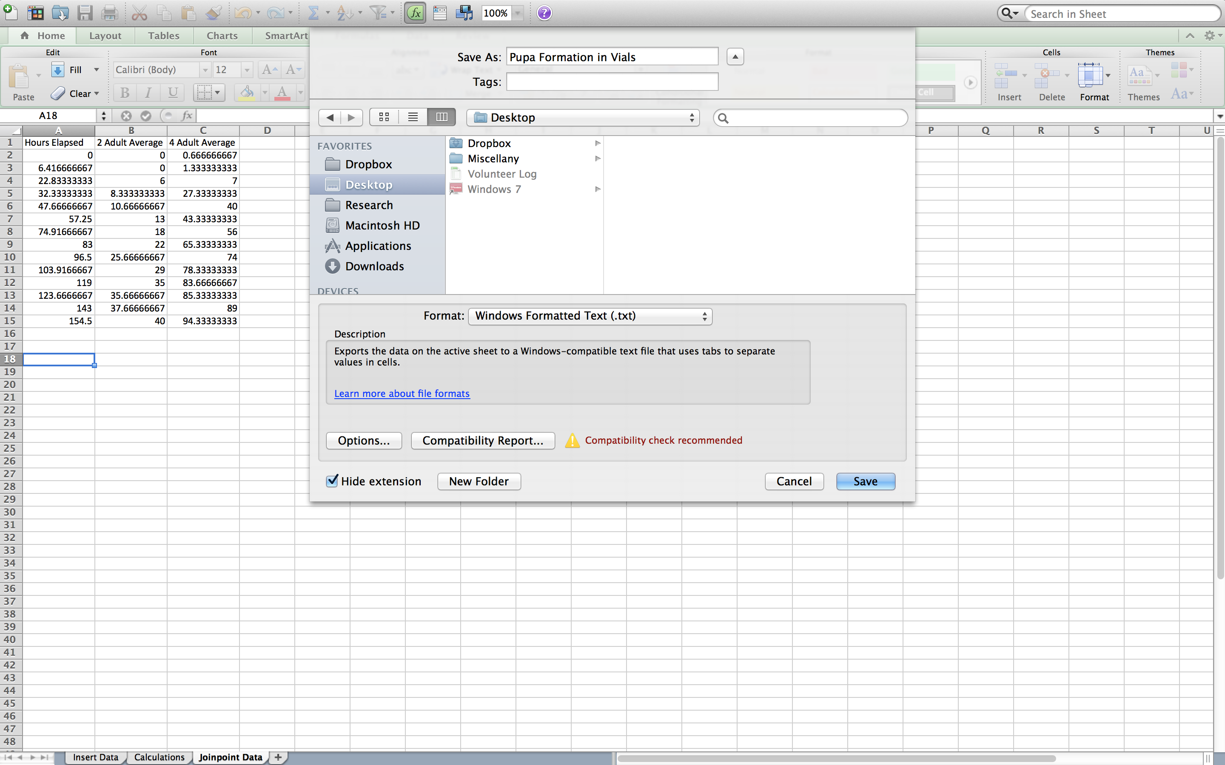

- You may be prompted with two popups. You will want to “Save Active Sheet” and “Continue” when prompted.
- Using the video from step 2 as a guide, please remove the extraneous information from the data file. Once it is properly prepared, properly save it for Joinpoint analysis.
- This saves the data in a format that Joinpoint can open. To continue analyzing the data, you will need to download and install Joinpoint from their website (https://surveillance.cancer.gov/joinpoint/download). You will have to fill out a brief form, and you’ll receive an email with download information.
- Once it is installed, open the program and navigate to “File,” then “New,” then “Blank Session.”
- A new window will open. In the “Input Data File” box, you will want to “Browse” and locate the .txt file you saved from Excel. Once you found it, click to open.

- Another window should open similar to the one below. In the “Dependent Variable Information” section, click “Provided” and “Count” under “Type.” Press “Ok.”
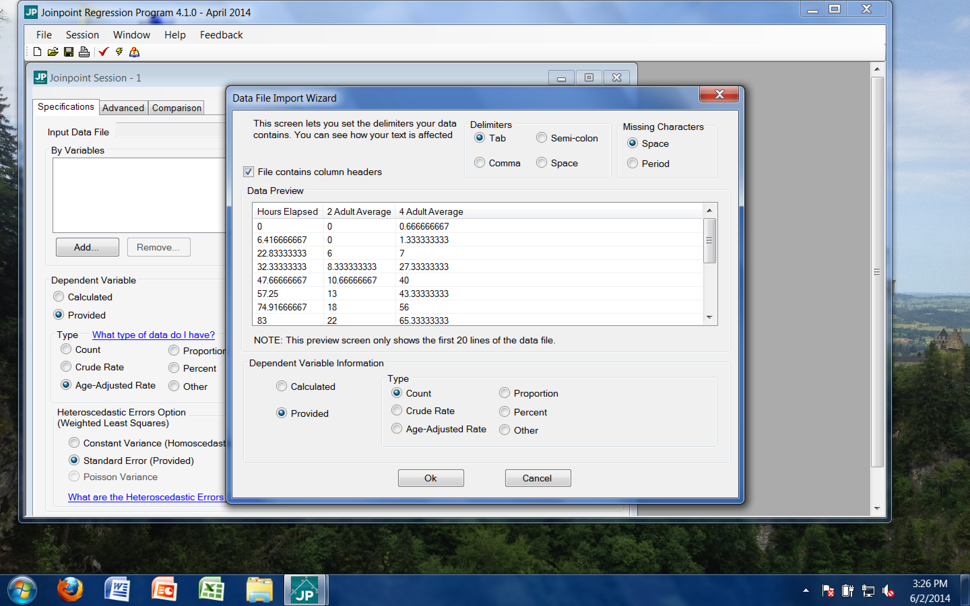
- When prompted to keep current variable definitions, click “No.”
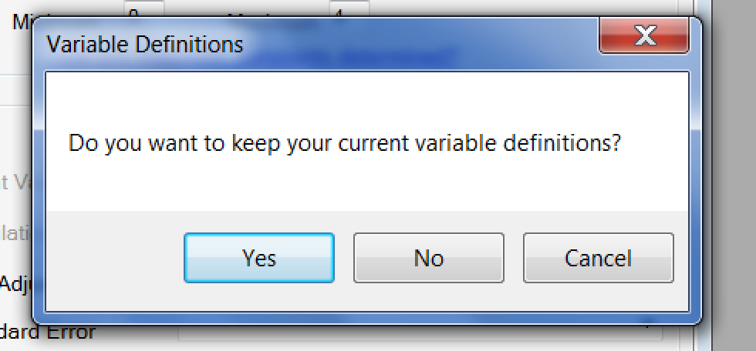

- Then adjust all values to reflect those in the following screenshot. Independent Variable should be “Hours Elapsed,” maximum number of Joinpoints should be “4,” count variable should be “2 Adult Average,” errors option should be “Constant Variance,” and log transformation should be “No.”
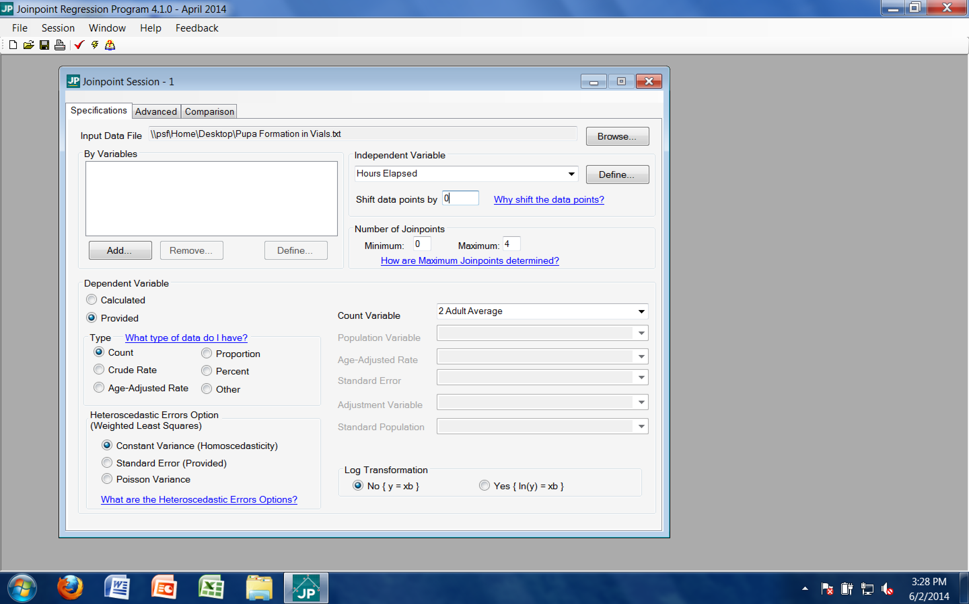
- After all of those settings have been adjusted, click on the little lightning bolt on the tool bar. It is between a checkmark and a book with a question mark. This will execute the analysis of the data.
- Once it is finished, a window will open with the output of the analysis. The Joinpoint software will analyze the data and complete piecewise linear regressions. This will result in a graph including the data points and lines of fit for the data. These lines, and particularly their slopes, will be useful in drawing conclusions.

- Before we examine the output, the graph must be properly labeled. Click on the “Display Options” button in the toolbar. It looks like a hand holding a piece of paper.
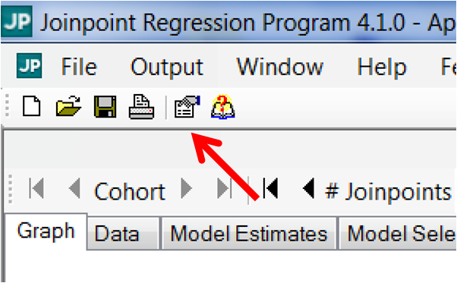

- From this menu, appropriate axis labels and title can be added to the graph. The x-axis should be labeled to reflect the independent variable (elapsed hours), and the y-axis should be labeled to reflect the dependent variable (number of pupa formed, in this case). The title of the graph should reflect the conditions of this particular trial. For this analysis, the text should be similar to that below:
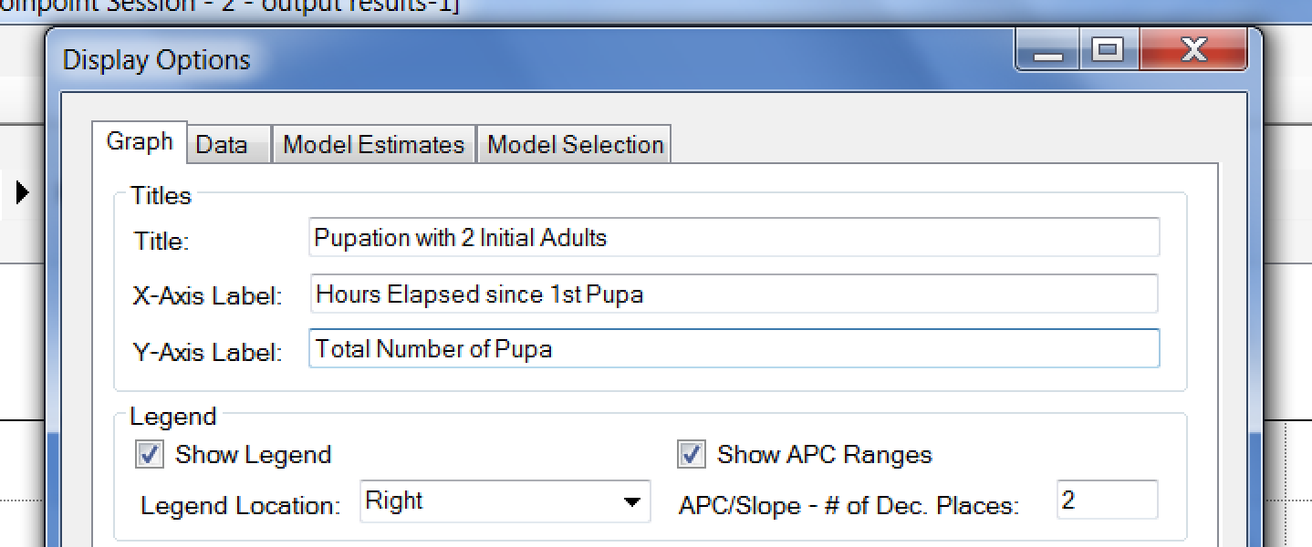

- Clicking “Apply” will add the labels to the graph. This should result in a graph that has all of the necessary elements to properly draw conclusions. For now, we will save the graph for later analysis. Go to the “Output” on the toolbar and click “Export.”
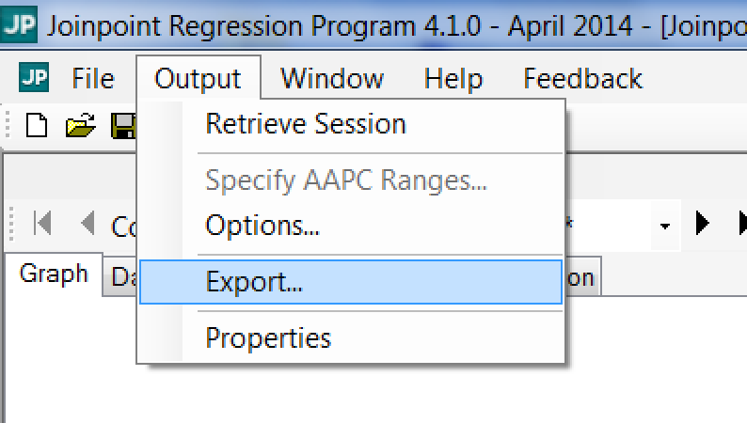

- In the Export menu, ensure the check box for “Displayed Graph” is checked and browse for a location to save it that you will remember. Name the file the same as the graph title. In this case, the file would be named “Pupation with 2 Initial Adults.” The options should appear similar to that below:
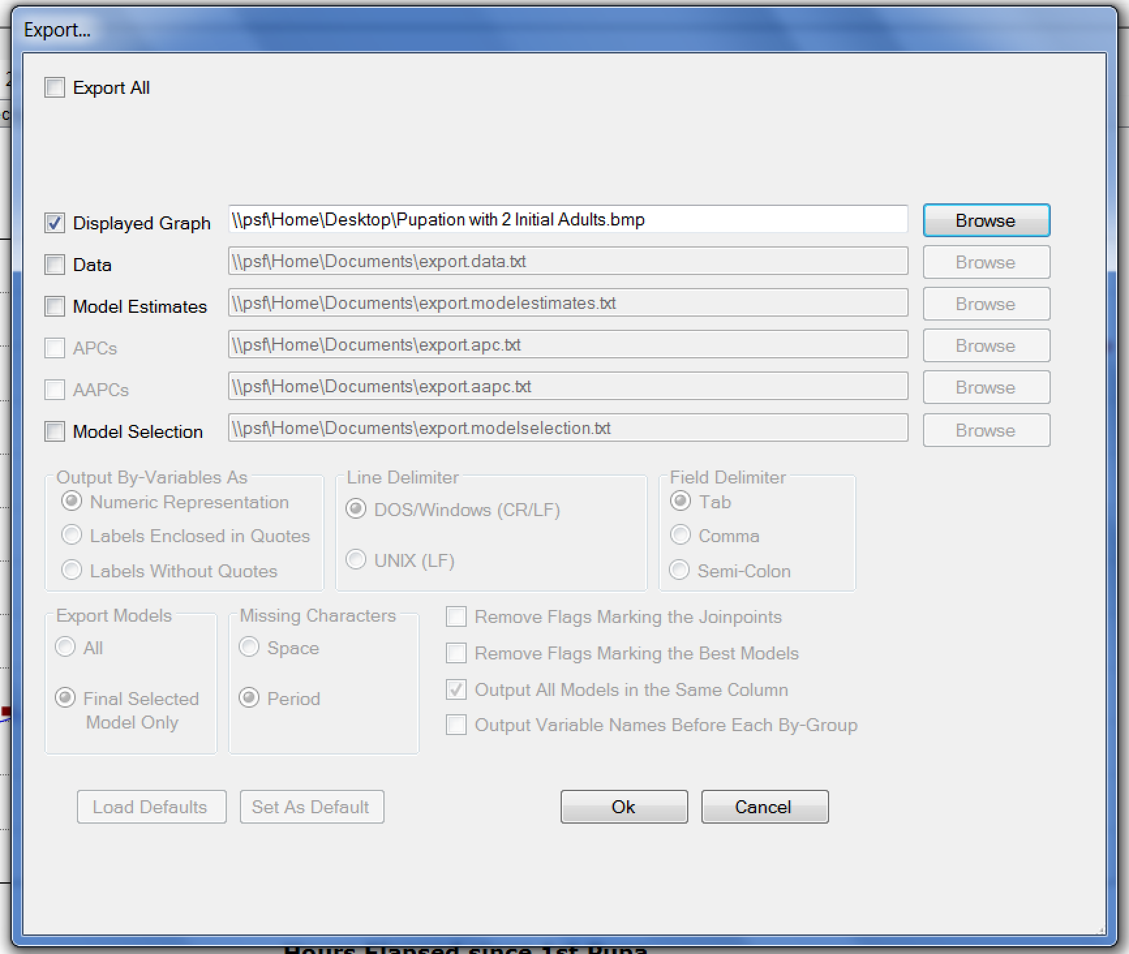
- Clicking “Ok” will export the graph to the designated location in picture format. In this case, the graph was saved as a file on the desktop. Please save this graph for further analysis.
- Now that you have prepared the graph and regressions for the portion of the trial with 2 initial adults, the portion for 4 initial adults must be addressed. To begin this, go to the “Output” button on the toolbar and navigate to “Retrieve Session.”
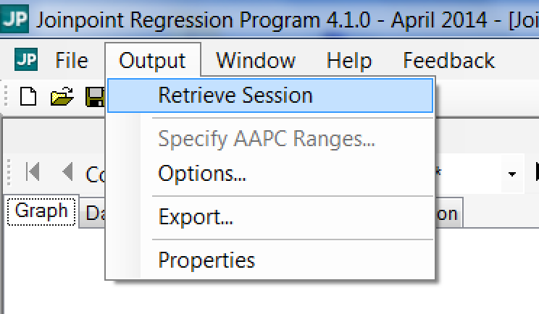
- This should open the menu seen previously in step 11. Only one of these quantities needs to be changed. “Count Variable” should be changed from “2 Adult Average” to “4 Adult Average.”
- At this point, recomplete steps 12 through 18 for the trial with 4 initial adults. Anywhere “2 Initial Adults” appears replace it with “4 Initial Adults.” At completion, there should be two graphs properly labeled and exported.
- The Joinpoint file should be saved in case something needs to be revisited later.
- Recomplete the above process (steps 1-22) for the adult eclosion data. Once all data analysis has concluded, there should be a total of four graphs.
Reading Joinpoint Graphs:
- At this point, you should have successfully exported four graphs from Joinpoint. We will start by looking at the graphs of pupation data. There should be a graph for each of the two pupation trials: 2 initial adults and 4 initial adults. Open both files from the location where you saved them.

- Let’s start by comparing the graphs. Between the two graphs, discuss differences in overall shape, steepness of the lines of fit, and overall number of pupa.

- On the right side of each graph, there should be a legend that displays the slopes of the regression lines for that graph. Look at the example taken from a trial with 4 initial adults:
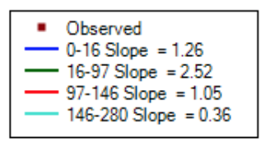
In this example, there are four piecewise regressions. The first one ranges from the beginning of the trial to when 16 hours had elapsed. The second ranges from the 16-hour mark to when 97 hours had elapsed, and so on. Next to the domain of each regression, the slope for that portion is identified. Please make note of the domain and slope of the regressions for each of your two graphs.

- From mathematics, we know that the slope corresponds to the rate at which something happens. A higher slope means something is happening more quickly than something with a lower slope. In this example, a higher slope indicates that, during that period, more pupa formed than in the period with the lower slope. Looking at the slopes from the example above, it would appear that pupa formation was steady at the beginning, increased to a faster rate in the middle, and slowed down towards the end of the trial. This conclusion is drawn from the magnitude of the slopes during these phases.

For each of the two trials for which you have data, characterize how the pupation rate changed over the duration of the experiment. What patterns do you notice? Do the trials differ in how the rate changes over the duration of the experiment? If so, how?

- Now examine how pupation rate differs between the two trials. Compare them on a piece-by-piece basis. Looking at the beginning, middle, and end of each trial, how do they compare? Is one of them consistently faster than the other? If so, which one?

- Complete the above section (steps 1-5) with the graphs made from adult eclosion data. Answer all of the questions using those graphs. In addition, briefly compare the findings between the pupation and eclosion data. Are the graphs more similar within each trial (pupation graphs more similar to one another than either is with eclosion graphs) or within each initial population size (graphs for initial population of two adults are more similar to each other than their respective graphs within each trial of four initial adults)?

Drawing Conclusions
At this point, you have formed a hypothesis related to how initial population size may impact how quickly a population grows, collected data from an experiment to test that hypothesis, and analyzed the data to make it easier to draw conclusions. Now it is time to build on everything you’ve done and draw conclusions from the analysis. Review your responses to the questions in the “Reading Joinpoint Graphs” section.

Conclusion questions:
- Is there a relationship between initial population size and how quickly the population grows with respect to both sets of data? If so, what is it?
- Does this observed relationship support or refute the hypothesis from earlier? Why or why not?
- Do the observed results align with what you already know about reproduction?
- Based on your results, which sex is more important for a population to grow quickly? Why might this be?

Challenge questions:
- Is it ever possible for the eclosion data to give a different result from the pupation data? If so, how? If not, why? Please consider how this experiment was designed and the basics of the fruit fly life cycle.
- Is the data collected from the experiment enough to conclusively show that one sex is more important in determining population growth rate? If so, how? If not, how would you alter the experiment to allow for this conclusion?
- If fruit flies were asexual and each was capable of reproducing by itself, would the data from the two and four initial adult trials have looked differently? Why or why not? If so, how?

